FRANCE
Your first visit to France won't be your last - prepare yourself for a long love affair. Whether the romance of Paris sweeps you off your feet or you fall gently for the relaxed life of Provence, France is a place for lovers, and will leave you spellbound.

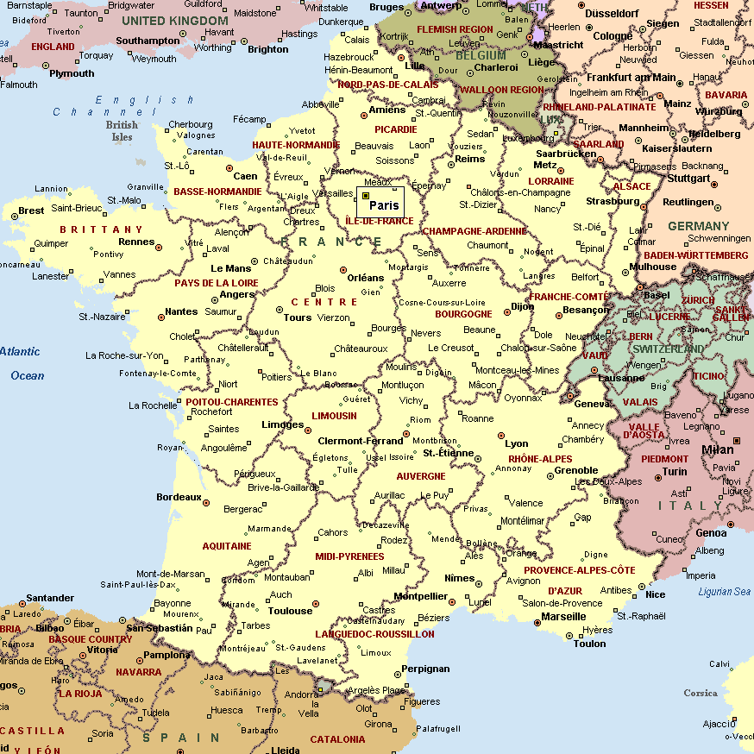

VISA:
The visa is to be obtained prior to arrival in the country

International Airports in France

International Airport | Airport Name
Paris | Orly | 14 Kms south of Paris
Paris | Charles de Gaulle (Roissy) | 23 Km northeast of Paris
French Riveria (Nice) | Cote d’ Azur International Airport | 7 km from Nice city centre; 27 km from Cannes; 33 kms from Monaco
Rhone Alps - Lyon | Lyon St Exupery
Lyon | Geneva Airport

CURRENCY:
Currency: Euro (EUR). EUR1 = 100 cents. Banque de France will exchange French Franc banknotes until January 2012.
Notes: EUR5, 10, 20, 50, 100, 200 and 500
Coins: EUR1, 2 and 1, 2, 5, 10, 20 and 50 cents
Credit cards: All major credit cards are widely accepted.
All major currencies can be exchanged at major branches of banks. Watch out for "Crédit Mutuel" or "Crédit Agricole" which have longer opening hours. Some first class hotels will also exchange foreign currency but shops and smaller hotels are prohibited to accept it by law. Traveler’s cheques are widely accepted.
One of the best ways to obtain money is to draw cash from ATMs (guichets automatiques), using an international credit or debit card. ATMs are available throughout France in all towns and cities and can be found outside banks and post offices. Access to machines is more limited outside of urban centers. A four digit PIN is used for most European ATMs. Check with your bank before you travel to make sure your PIN will work in Europe. Check also which ATM systems are compatible with your card.
Paris has many automatic teller machines that can be used to withdraw cash 24 hours a day. At weekends, however, machines can run out of money quickly. Bureaux de Change is widespread in tourist areas

GETTING AROUND:
Getting There
Air : The main gateways to France is Paris.
Train: Rail services link France with every country in Europe. Paris is the country’s main Hub, with services to/from every part of Europe. France is a home to the world renowned High Speed TGV trains which offer extremely efficient connections within the country.
The Channel Tunnel in 1994 has meant travel between England and France on the ultra modern Eurostar rail service- is now quick and hassle free PAR – LON 2hrs 30 min. by Eurostar
Bus: Paris is the country’s main bus hub, with connections to and from every part of Europe. Buses are slower and less comfortable than trains, but they could be cheaper.

CLIMATE
Four climactic types prevail in France. A true temperate maritime climate is found in the west, near the coasts, and is exemplified at BREST, where winters are mild (7 deg C/45 deg F in January), summers are cool (16 deg C/61 deg F in July), and rainfall is frequent (800 mm/32 in) during 180 days of the year. A mid-latitude continental climate prevails in the interior of the country, with hotter summers (average July temperature of 18 deg C/64 deg F in PARIS) and more rigorous winters (average January temperature of 2 deg C/36 deg F in Paris), and rain falls on fewer days of the year.

TIME:

Italy is 4 hours and 30 minutes behind India. (Subtract one hour for DST from March to October)

CLOTHING:

Light weight to tropical in the southern regions, with a pullover for the hilly regions. A raincoat is useful all year round in the northern regions. During the winter you are advised to bring a warm overcoat & medium weight clothes.

ELECTRICITY:
The voltage used is 220 volts, AC 50Hz.

DAILING CODE:
International dialing code: 33
Area codes: Paris 1; Nantes: 2, Strasbourg: 3, Nice: 4, Bordeaux: 5
Area codes are preceded by 0 when dialing within the country.
Most public telephone phone boxes use phone cards, Télécarte, which can be purchased from post offices and tobacconists (Tabac). Incoming calls can be received on boxes displaying a blue bell sign. During weekdays from 19h00-08h00 and Saturdays from 14h00, you can make cheap calls (50% extra time free).

TIPS:
Service is usually included in your restaurant or bar bill and represents 15% of the bill. If you are particularly satisfied with the service, then an extra tip of 10% of the bill is customary. It is the norm to tip porters EUR1.50 per bag, chambermaids EUR1.50 per day and taxi drivers 10% of the fare. It is also customary to tip tour guides and bus drivers EUR1.50-3, depending on the service received.

LANGUAGE:
French is the official language, though in the hotels and your guides are well versed in English.

SHOPPING and MUST BUYS:
In France a sales tax (VAT) of 19.6% is levied on most goods and services. Following a visit to France, non-EU tourists can apply for a tax refund on goods bought. Most countries offering a tax refund specify a minimum amount that must be spent in a particular shop to claim a refund. In France, the minimum purchase to qualify for a refund is EUR175.
To reclaim tax you need to request a VAT refund request form when you make a purchase, which states the amount of refund due. Customs officials must stamp these documents as you leave the country and the refund will be processed and sent to you.
Alternatively, you can purchase goods from shops participating in the Tax-free Shopping programme (look out for the Tax-free Shopping logo displayed in the window). Simply show your passport when you make a purchase and you will be given a Tax-free Shopping cheque showing the refund you are owed. As you leave the country, customs officials will stamp your cheques. You can claim your refund from the Tax-free Shopping desk or have it sent to you.
Shopping can be done at Bercy Village, Galerie Lafayettes, Printemps, Marche aux flower market, La Vallee Village
HEALTH CONCERNS
The water supply throughout France is safe for drinking.
The quality of healthcare in France is extremely high, and so are the fees. Tourists are heavily advised to have travel insurance including health cover before they travel
Every arrondissement has at least one police station.

Emergency Numbers:
Police: Tel: 17 or 112
Ambulance: Tel: 15 or 112
Fire: Tel: 18 or 112
Health Concerns
PERSONAL SAFETY
France has a low crime rate but tourists can encounter incidents of pick pocketing and petty theft, especially on trains, subways, museums, monuments, restaurants, hotels and beaches. Ensure that you keep your personal belongings safe at all times and secure your passport in a hotel safe during your stay. In Nice, Antibes, Cannes and Marseille theft from parked cars and cars stopped at red lights is common. If you hire a car during your stay, always lock the door and ensure that valuable belongings are not left in view.

Eurostar
A large number of visitors now arrive in Paris by the Eurostar train. This international train-link runs to London via the Channel Tunnel and to other destinations on the continent. Trains arrive at the Gare du Nord, located just to the north of the city centre. The station is also a hub for the Métro and RER networks, which connect to the city centre.

The following table provides approximate driving distances between French cities. Kilometres in the lower left of the table, miles in the upper right.
 | Par | Cal | Tou | Val d' | Nic | Mar | Lyo | Toul | Str | Bor | Bay
Paris | • | 179 | 147 | 435 | 576 | 480 | 289 | 429 | 303 | 363 | 163
Calais | 289 | • | 326 | 612 | 755 | 660 | 468 | 687 | 385 | 542 | 230
Tours | 237 | 525 | • | 500 | 628 | 533 | 366 | 362 | 445 | 217 | 172
Val d'Isere | 697 | 985 | 806 | • | 255 | 290 | 143 | 426 | 304 | 575 | 596
Nice | 927 | 1215 | 1011 | 410 | • | 126 | 289 | 396 | 488 | 495 | 740
Marseilles | 723 | 1061 | 858 | 468 | 203 | • | 194 | 250 | 493 | 399 | 643
Lyon | 465 | 752 | 588 | 230 | 456 | 312 | • | 334 | 301 | 483 | 451
Toulouse | 690 | 1103 | 582 | 686 | 557 | 402 | 537 | • | 629 | 140 | 534
Strasbourg | 487 | 621 | 716 | 489 | 786 | 794 | 485 | 1021 | • | 661 | 470
Bordeaux | 589 | 872 | 350 | 926 | 796 | 643 | 777 | 240 | 1063 | • | 390
Bayeux | 263 | 371 | 277 | 959 | 1189 | 1035 | 726 | 859 | 755 | 627 | •

CITIES:

PARIS

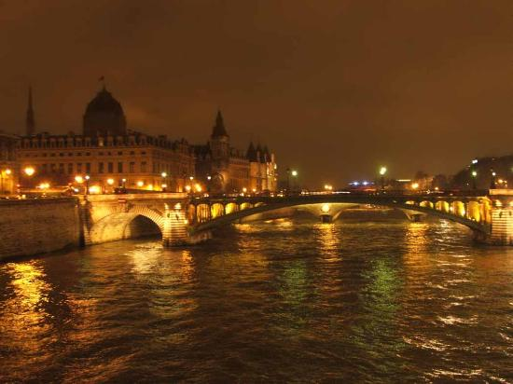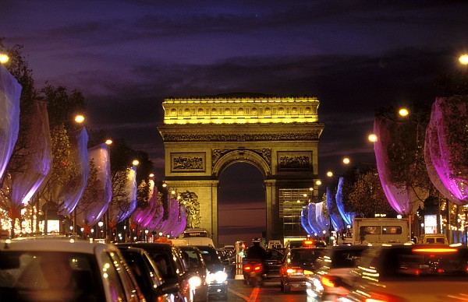

From its cities, steeped in art and history, to its stunning and varied countryside France boasts some of the most beautiful locations in the world. Below are some top attractions in Europe's most sophisticated country. Paris is a very compact city. The river seine divides Paris into the Right Bank to the north and the Left Bank to the south. 32 bridges link the banks of the Seine, some providing to the 2 small islands at the heart of the city, Ill de La Cite – the city’s birth place and the site of Notre-Dame, and Lle st-Louis.
The main street is on the Right Bank is the Champs-Elysees, beginning at the Arc de Triomphe.

Getting There
Air: Paris has 02 International airports Orly and Charles de Gaulle. From Charles de Gaulle Airport, there is a shuttle bus which transports passenges to the Roissy rail station, from which you can board fast RER trains FOR Such Metro Stations as Gare du nord, chalet, Luxemburg. You can also take either of 02 Air France shuttle buses, both of which depart from Roissy for points within central Paris.
Taxis: Taxis from Roissy into the city run approx 40Euro on the meter.
Buses: From Orly, an Air France bus leaves for Gare des Invalides in Central Paris at a cost of 11Euro approx one-way. Other buses depart for place Denfert-Rochereau in south of Paris. There's a direct bus service from Orly to Denfert-Rochereau, which is supposed to take around 30 minutes, but the drop-off point isn't that helpful.

Driving
Driving in Paris centre can be a stressful experience. Parisian drivers are generally impatient and liberal users of both horn and hand gesture. However, if you adopt a thick skin (as most local drivers do) it is possible to drive with reasonable confidence. Be aware that vehicles entering from the right have right of way, but often the congestion is such that it is a case of filtering in where you can.
There is a pollution prevention measure restricting the use of cars in the city on days when the air-quality is particularly poor, with cars being restricted according to whether they have an odd or even numbered license plate. On such days public transport is free. The restriction does not apply to many modern cars that have low emissions - hire cars are usually in this group and exempt from restrictions.
An International Driving License is required for Indian citizens. The minimum driving age is 18. Driving is on the right and you must overtake on the left-hand side. The driver and all passengers in the front and rear of the car must wear seat belts where fitted. Children under ten are not permitted to travel in the front seat.
On motorways where a toll is payable, payment is made by credit card or cash and depends on the distance traveled. You will be given a ticket on entry and must produce it later for payment. You should be aware that there is a time on the ticket and paying for a ticket one hour later some 150km down the road will show that you must have exceeded the speed limit. On the spot fines of up to EUR800 approx can be demanded for speeding offences, so it is wise to adhere to restrictions.
All the major car rental firms are represented in Paris. Most companies also have desks at the airport for immediate car pick-up.

Trains: There are 6 major train stations in Paris: Gare d’ Austerlitz, serving the southwest, with trains from the Loire Valley, the Bordaux county and the Pyrenees
Gard de l’Est, serving the east, with trains from Strasbourg, Nancy, Reims and beyond to Zurich, Basel, Luxembourg and Austria
Gare de Lyon: serving thr southeast with trains from Cote d’ Azur and Province to Geneva, Laussane and ITALY
Gare Montparnasse serving rhe west with trains from Brittany
Gare du Nord serving the north, with trains from Holland, Denmark, Belgium and Germany
Gare St-Lazare serving the northwest. With trains from Normandy
Eurostar Express has dalily services from London to both Paris and Brussels. The 50 Km journey takes 35 min. though the actual time spent in the Chunnel is only 19 min.

Getting Around
Paris is a city of strollers who enjoy strolling.

Metro and RER
The Metro is the most efficient and fastest means of transportation in Paris. Buses are much slower than the Metro.
Paris has a really excellent underground system, the Metro, supplemented by the RER stations in the centre, for which you can use a Metro ticket. The Metro operates between 05h30 and 01h30, the RER between 05h00 and midnight. Trains are extremely frequent. Metro stops tend to be close together, meaning that every attraction is only a short walk from one station or another.
If you're not likely to get your money's worth from a "Paris Visite" card (see above), the most sensible way to buy tickets for a short stay is by investing in a carnet of ten tickets. Each ticket entitles you to one journey on any public transport in the city. On the Metro network you can change lines as often as you like on a single journey without using a new ticket.
It can be difficult to decipher the stations on the Metro map. As well as finding your station, you'll also need to remember the stations at the end of the line you want to use, as in the corridors you're directed not just by the line number, but also by the final destinations

The Batobus is a 150 passenger ferry with big windows. Every day between April and December the boats operate along the river Seine, stopping at points of interest: The Eiffel Tower, Musee d’Orsay, the Louvre, Notre-Dame ad the Hotel de Ville. Unlike the Bateaux-Mouche, it does not provide recorded commentary

Central Paris is officially divided into 20 districts called arrondissements, numbered from 1 to 20 in a clockwise spiral from the center of the city (known as Kilometre Zero and is located at the front of Notre Dame). Arrondissements are named according to their number. You might, for example, stay in the "5th", which would be written as 5e (SANK-ee-emm) in French. The 12th and 16th arrondissements include large suburban parks, the Bois de Vincennes, and the Bois de Boulogne respectively.
The very best map you can get for Paris is called "Paris Pratique par Arrondissement" which you can buy for about €2 at any news stand. It makes navigating the city easy- so much that one can imagine that the introduction of such map-books might be part of what made the arrondissement concept so popular in the first place.
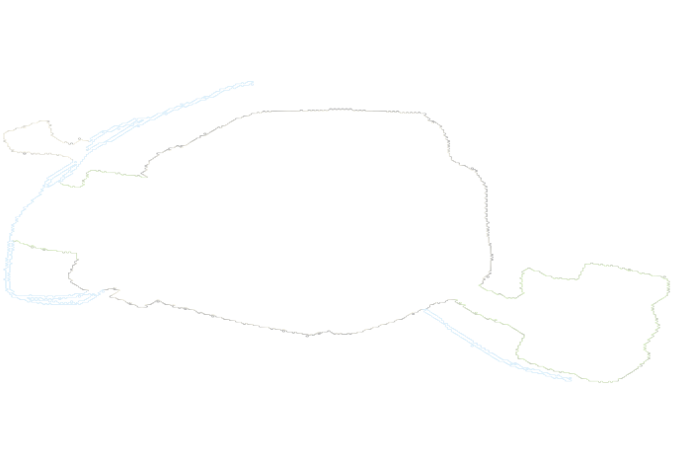

1st (1er). The geographical center of Paris and a great starting point for travelers. The Musée Louvre, the Jardin des Tuileries, Place du Vendôme, Les Halles, Palais Royal, Comédie-Française, and Arc de Triomphe du Carrousel are all to be found here.
• 2nd (2e). The central business district of the city - the Bourse (the Paris Stock Exchange), Opéra-Comique, Théâtre des Variétés, Passage des Panoramas, Théâtre des Bouffes Parisiens and the Bibliothèque Nationale are located here.
• 3rd (3e). Archives Nationales, Musée Carnavalet, Conservatoire des Arts et Métiers, Musée Carnavalet, Hôtel de Soubise, the Former Temple fortress, and the northern, quieter part of the Marais can be found here.
• 4th (4e). Notre-Dame de Paris, the Hôtel de Ville (Paris town hall), Hôtel de Sully, Rue des Rosiers and the Jewish Quartier, Beaubourg, Le Marais, Bazar de l'Hôtel de Ville, Centre Georges Pompidou, Place de Vosges, Bibliothèque de l'Arsenal, Saint-Jacques Tower and Parisian island Île Saint-Louis can be found here.
• 5th (5e). Jardin des Plantes, Muséum National d'Histoire Naturelle, Musée de Cluny, The Panthéon, Quartier Latin, Universités, La Sorbonne, Bibliothèque Sainte-Geneviève, Église Saint-Séverin, La Grande Mosquée, Le Musée de l'AP-HP can be located here.
• 6th (6e). Jardin du Luxembourg as well as its Senat, Place Saint-Michel, Église Saint-Sulpice and Saint-Germain des Prés can be found here.
• 7th (7e). Tour Eiffel and its Parc du Champ de Mars, Les Invalides, Musée d'Orsay, Assemblée Nationale and its subset administrations, Ecole Militaire, and Parisian mega-store Le Bon Marchee can be found here.
• 8th (8e). Champs-Elysées, Arc de Triomphe, Place de la Concorde, le Palais de l'Elysée, Église de la Madeleine,Jacquemart-Andre Museum, Gare Saint-Lazare, Grand Palais and Petit Palais can be found here.
• 9th (9e). Opéra Garnier, Galeries Lafayette, Musée Grévin, and Folies Bergère can be found here.
• 10th (10e). Canal Saint-Martin, Gare du Nord, Gare de l'Est, Port Saint-Denis, Port Saint-Martin, Passage Brady, Passage du Prado, and Église Saint-Vincent-de-Paul can be found here.
• 11th (11e). The bars and restaurants of Rue Oberkampf, Bastille, Nation, New Jewish Quarter, Cirque d'Hiver, and Église Saint-Ambroise can be found here.
• 12th (12e). Opéra Bastille, Bercy Park and Village, Promenade Plantée, Quartier d'Aligre, Gare de Lyon, Cimetière de Picpus, Viaduc des arts the Bois de Vincennes, and the Zoo de Vincennes can be found here.
• 13th (13e). Quartier la Petite Asie, Place d'Italie, La Butte aux Cailles, Bibliothèque Nationale de France (BNF), Gare d'Austerlitz, Manufacture des Gobelins, Butte-aux-Cailles and Pitié-Salpêtrière Hospital can be found here.
• 14th (14e). Cimetière du Montparnasse, Gare Montparnasse, La Santé Prison, Denfert-Rochereau, Parc Montsouris, Stade Charléty, Cité Internationale Universitaire de Paris, and Paris Catacombs can be found here.
• 15th (15e). Tour Montparnasse, Porte de Versailles, Front de Seine, La Ruche and quartiers Saint-Lambert, Necker, Grenelle and Javel can be found here.
• 16th (16e). Palais de Chaillot, Musée de l'Homme, the Bois de Boulogne, Cimetière de Passy, Parc des Princes, Musée Marmottan-Monet, Trocadéro, and Avenue Foch can be found here.
• 17th (17e). Palais des Congrès, Place de Clichy, Parc Monceau, Marché Poncelet, and Square des Batignolles can be found here.
• 18th (18e). Montmartre, Pigalle, Barbès, Basilica of the Sacré Cœur, Église Saint-Jean-de-Montmartre, and Goutte d'Or can be found here.
• 19th (19e). Cité des Sciences et de l'Industrie, Parc de la Villette, Bassin de la Villette, Parc des Buttes Chaumont, Cité de la Musique, Canal de l'Ourcq, and Canal Saint-Denis can be found here.
• 20th (20e). Cimetière de Père Lachaise, Parc de Belleville, and quartiers Belleville and Ménilmontant can be found here.
• La Défense. Although it is not officially part of the city, this skyscraper district on the western edge of town is on many visitors must-see lists for its modern architecture and public art.

MUST SEES:

Arc de Triomphe
Located on the Rive Droite, almost directly north from the Eiffel Tower, the Arc de Triomphe was intended to be a monument to Napoleon's military power commissioned by the Little Corporal in 1806. It has since been at the centre of much of Paris's history. From the top you can enjoy excellent views of Paris, particularly down the Grand Axe from the modern business centre of La Défense to the Champs-Elysées and the Louvre.
Location: Charles de Gaulle, 8e. Tel: +33 (0)1-5537-7377 Opening Hours: 10h00-22h30 (Oct-Mar); 10h00-23h00 (Apr-Sep). Free to all on the first Sunday of each month Feb-May to get there Metro: Charles de Gaulle-Etoile.

Notre Dame
On Lile de la Cite in the middle of the Seine, the magnificent Gothic cathedral of Notre Dame has now been greatly restored to its former glory. You can generally only see a limited amount of the interior, but it is still well worth a visit to see the stunning rose windows in the nave. The cathedral holds about 6000 people. If you're Catholic, attending mass here is particularly uplifting. For a fee, you can climb to the top of Notre Dame's towers which has about 387 steps and gaze down at the city along with the gargoyles that perch atop its walls.
Location. Place du Parvis Notre Dame, 4e. Tel: +33 (0)1-4234-5610 Opening hours: daily 09h30-19h30. Admission: free to the nave. Free guided tours available in various languages. To get there- Metro: Cite/St-Michel.

Effile Tower
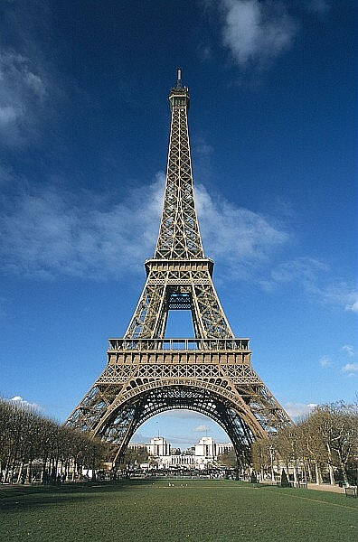
One of the world's most famous monuments, La Tour Eiffel is an unmistakable feature of the Paris skyline. Designed by Gustav Eiffel for the 1889 World Fair, when completed the tower was the tallest building in the world at 300 metres. It is no exaggeration to say that the Eiffel Tower is the symbol not only of Paris but of the entire country. Although no longer the tallest structure in the world it still offers one of the best vantage points from which to get your bearings in the City of Lights. Take the lift all the way up to level three for some spectacular views across Paris.
Famously the construction was only intended to last the duration of the fair. However, over a century after its erection the tower is still as sturdy as ever. To avoid the queues come early in the morning - or visit at night when the tower is lit up with over 10,000 lights.
Going up (daily: mid-June to Aug 9am–midnight; Sept to mid-June 9.30am–11pm) costs €9.90 (for the top; access closes at 10.30pm), you can also climb the stairs as far as the second level (access to the stairs closes at 6pm from Sept to mid-June). Paris looks surreally microscopic from the top and though the views are arguably better from the second level, especially on hazier days, there's something irresistible about taking the lift all the way. The view is, of course, the main attraction, but you can also peer through a window into Eiffel's airy little show-off study, at the very top, while at the second level is the hyper-gastronomic restaurant, Jules Verne.
Champ de Mars, 7e. Tel: +33 (0)1-4411-2323. Opening Hours: daily 09h30-23h00 To get there - Métro: Bir-Hakeim or RER Champ-de-Mars.
The Louvre
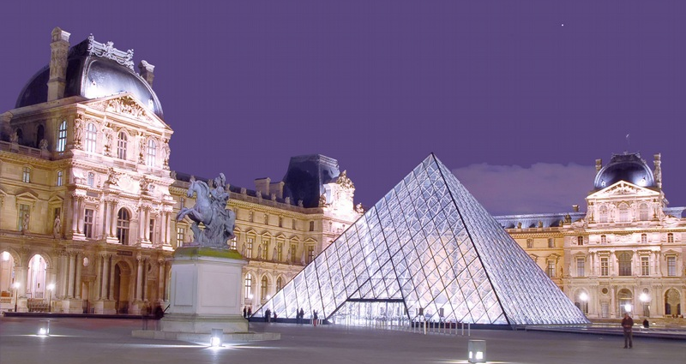
A colossal French royal château turned into the greatest art museum in the world, the Louvre is the most famous building on the Rive Droite of the Seine. The main entrance is via the mesmerising glass pyramid designed by IM Pei and opened in 1989. First-timers tend to go straight for Leonardo da Vinci's Mona Lisa in the extensive Italian collections, and visitors sometimes forget that the gallery boasts a superlative array of French masterpieces, as well as phenomenal French and foreign sculpture galleries. As if that wasn't enough, the vast place also contains one of the largest collections of ancient treasures in the world, including staggering Egyptian artefacts brought to France after the Napoleonic campaigns.
Location: Musée du Louvre. Palais du Louvre, 1er. Tel: +33 (0)1-4020-5317. Opening hour: Wed-Mon 09h00-18h00 (until 21h45 Mon & Wed). Free to all visitors on the 4th Sunday of every month. Louvre is closed on all Tuesdays To get there - Métro: Palais-Royal-Musée du Louvre
Louvre will be closed on 1st May and 8th May 2008

Sacre Coer- Montmartre
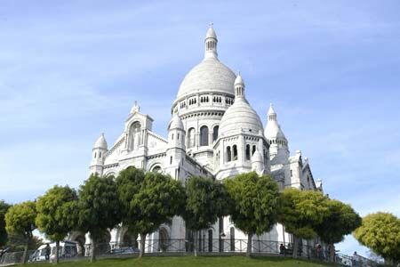
The "Hill of the Martyrs", named after early Christians persecuted by the Romans, lies north of the city centre and is crowned by the magnificent Sacré Coeur. Montmartre became the haunt of countless artists in the 19th century and virtually everything in the area is devoted to their memory. The very pretty Place du Tertre is the heart of touristy Montmartre but beyond the square you can find seclusion from the crowds. With its many domes visible from afar across Paris, the white Basilique du Sacré Coeur, atop Montmartre, raises more like a fabulous oriental palace than a church. The place is magnetically kitsch inside and out, although the Benedictine nuns and their hymns create a suitably religious atmosphere each day of the week for mass. From in front of the basilica the views over Paris are exhilarating.
Beside the basilica is the lovely Gothic church of St Pierre, all that remains of the royal abbey of Montmartre which was destroyed during the Revolution.
Location: 35 Rue du Chevalier de la Barre, 18e. Tel: +33 (0)1-5341-8900 Opening Hours: daily 06h00-23h00. To get there- Métro: Abbesses/Anvers.
Musée d'Orsay
The main challenger to the Louvre, the Musee d'Orsay lies on the Rive Gauche of the Seine opposite the royal palace. This splendidly pompous building went up at the very end of the 19th century, having been designed by Victor Laloux as a railway station for the 1900 Paris World Fair. Saved from destruction in the 1970s, it was transformed into an art museum, taking up the story of French art where the Louvre leaves off, up to the outbreak of the First World War in 1914. The magical works of Impressionists such as Monet, Renoir, Degas, Van Gogh, Cezanne and Pissarro are the highlights.
Location: Quai Anatole France, 7e. Opening Hours: Tue-Wed & Fri-Sat 09h30-18h00, Thu 10h00-21h45, Sun 09h00-18h00. Tel: +33 (0)1-4049-49 Free to all visitors on the first Sunday of each month. To get there: Metro: Solférino or RER Musee d'Orsay.
Pantheon
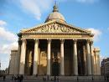
Soufflot originally built the enormous domed Pantheon on the Rive Gauche as a church for Louis XV. At the Revolution it was turned into a monumental temple to the memory of the great citizens of the French nation: Voltaire, Rousseau, Hugo, Zola and the Curies (Pierre and Marie), have all been given places among other famous French men and women through the ages.
Location: Place du Panthéon, 5e. Tel: +33 (0)1-4432-1804. Opening Hours: daily 10h00-18h30 (summer), 10h00-18h00 (winter). To get there: Metro: Cardinal Lemoine or RER Luxembourg.
The Pompidou Centre flaunting its plumbing on the outside and daubed in vulgarly bright colours, the bold and brash Centre pompidou caused a sensation when it first opened. The main attraction for tourists is the Musee National d'Art Moderne.
Here you can saunter past splendid works by the leading modern painters who shook the art world between the 1900s and the 1960s. The emphasis is on French artists, or those who lived in France. Picasso, Braque, Matisse and the likes count among the stars.
If you like the works of art on show here the city of Paris also has its own separate top-class modern art collection in the Palais de Tokyo.
Location: Centre Georges Pompidou, Place Georges Pompidou, 4e. Tel: +33 (0)1-4478-1233 Opening Hours: Wed-Mon 11h00-21h00. Free to all visitors on the first Sunday of each month. To get there: Métro: Hôtel de Ville/Rambuteau or RER Châtelet les Halles.
Musee National du Moyen Age
Medieval art is celebrated at the Musée National du Moyen Age, better known simply as the Cluny. The settings in this ornate if over-restored Gothic house, built on the site of Roman baths, may be slightly old-fashioned. However, you can't help but admire the tapestries of the Lady and the Unicorn, the original statues of the Kings of Judah from Notre Dame's façade and some of the finest church treasures in Europe.
Location: 6 Place Paul Painleve, 5e. Tel: +33 (0)1-5373-7816. Opening Hours: Wed-Mon 09h15-17h45 (opening times may vary). Free to all on the first Sunday of each month. To get there - Metro: Cluny-La Sorbonne or RER St-Michel.
Picasso Museum
Picasso spent many years in France, including the war years, and the Musée Picasso (in the Marais quarter on the Rive Droite) is crammed with works by the Spanish exile. The amazingly diverse works demonstrate how the genius developed his unique style through different periods.
Location: Musée National Picasso. Hôtel Salé, 5 Rue de Thorigny, 3e. Tel: +33 (0)1-4271-2521. Opening Hours: Wed-Mon 09h30-18h00 (Apr-Sept); 09h30-17h30 (Oct-Mar). Free to all on the first Sunday of each month. To get there- Metro: St-Paul.
Conciergerie
Paris's revolutionary history is covered in the Conciergerie, the remnants of a medieval royal palace on l'Île de la Cité. The building doubled as an infamous prison during the bloody uprising and was the place of Marie Antoinette's incarceration - from where she was taken to the guillotine on October 16, 1793.
Location: 1 Blvd du Palais, 1er. Tel: +33 (0)1-5340-6097 Opening Hours: daily 09h30-18h00 (Mar-Oct); 09h00-17h00 (Nov-Feb). To get there- Métro: Cite/Chatelet.
The nearby Espace Dali (Rue Poulbot, 18e. Tel: +33 (0)1-4264-4010) is filled with works by the surrealist Spanish artist, and not far off, in Rue Cortot, the Musee de Montmartre (12 Rue Cortot, 18e. Tel: +33 (0)1-4606-6111) proves an interesting local history museum. The village-like ambience of the area is heightened by a couple of old windmills, namely the Moulin de la Galette and the Moulin du Radet, and a patch of vineyard.
Military Museum
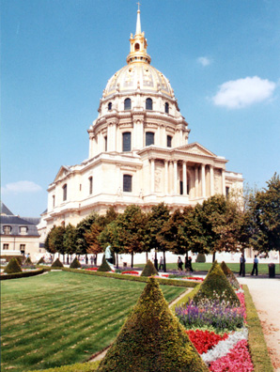
The military history of the whole of France, not just Paris, takes up large parts of the massive Les Invalides complex.
As the name implies, these buildings were originally constructed as a hospital for the huge number of soldiers wounded in King Louis XIV's wars. The complex now houses the Musée de l'Armee, the Musee des Plans-Reliefs and the Musee de l'Ordre de la Liberation.
France's proud military heritage is evident throughout, in an overwhelming wealth of paintings, engravings, uniforms and weapons. Of course Napoleon is well represented; displays include reconstructions of several of the Little Corporal's rooms, his death mask and one of his favourite horses, stuffed. Below the dome of Les Invalides's church lies Napoleon's elephantine tomb. A separate charge applies to visit Napoleon's tomb.
Location: Hôtel National des Invalides. 129 Rue de Grenelle, 7e; Tel: +33 (0)1-4442-3877. Opening Hours: 10h00-18h00 (19h00 for Napoleon's tomb). To get there- Metro: Invalides/Pont de l'Alma.
Views of Paris
The 196 metre-high summit of the Tour Montparnasse provides some of Paris's most impressive views. The building itself is nothing to look at (unless you have a soft spot for brutalist tower blocks) but take the super-fast lift to the 56th floor and you will be rewarded with a superb 360-degree vista of the city, taking in the iffel Tower, Sacré Coeur and all the other major landmarks.
Location: Rue de l'Arrivee, 15e. Open: daily 09h30-23h00. Admission: EUR8.50, adults; EUR5.80, children. Tel: +33 (0)1-4538-5256. Metro: Montparnasse-Bienvenue.
More interesting architecturally, and almost as good in the view stakes, in the heart of the city's business district the ultra-modern Grande Arche de la Defense stands as a modern-day Arc de Triomphe. A panoramic glass lifts transport visitors 110 metres to the viewing floor at the top - for a perfect view along the full length of the Champs Elysee. Parvis de le Défense. Open: 10h00-20h00. Admission: EUR7.50, adults; EUR6, children. Tel: +33 (0)1-4907-2727. Metro: Grande Arche de la Défense.
Lido Show
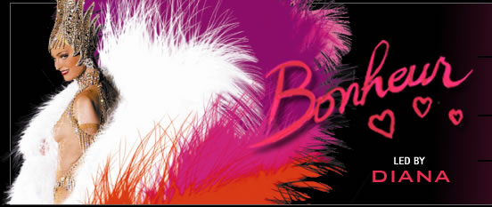
Paris always had a reputation as a city of celebration and entertainment. Located on the world’s most famous avenue Champs-Elysees, the Lido and its reviews have added sparkle to the city of lights since 1946. Come discover the Lido, “ the world’s most famous cabaret” and share the exhilaration and enchantment with us.

Cité des Sciences- interactive fun
A massive complex of multiple attractions at the Parc de la Villette, north-east of the city centre. Surrounded by uninspiring modern high-rise blocks, the place itself looks a bit daunting when you arrive. The main building was the largest slaughterhouse in the world until it was smartened up to become a massive science museum and high-tech centre called Explora. It's geared to children of all ages, with separate sections devised for three to five year olds and for six to twelve year olds, although the bulk of the place has been designed to appeal to teenagers. The star attraction of the whole complex is the separate new mirror ball of a building known as the Geode, where films are shown on a vast semicircular screen.
Open: Tue-Sat 10h00-18h00, Sun 10h00-19h00 (Explora); Tue-Sat 10h30-21h30, Sun 10h30-19h30 (Geode).
30 Avenue Corentin Cariou (19e), Métro: Porte de la Villette.

Paris Zoo -
A zoo with all the usual animals and attractions you'd expect. The kids will love Paris's zoo as much as kids always do. The big draws, as always, are the monkeys and the large cats. There is plenty of space for the animals to roam and the complex is undoubtedly one of the more modern of its kind. Note that Paris Zoo will have some work going on until early 2008 that might cause some disturbance.
Open: Mon-Sat 09h00-18h00, Sun 09h00-18h30.
53 av de St-Maurice, 12e. Métro: Porte Dorée.

Paris Catacombs - skeletons under the city
If you enjoy the idea of seeing old bones face to boney face, go down into the Parisian catacombs where you can admire whole walls built up of the things. The trip will definitely appeal to the macabre humour of most kids and is pretty interesting for adults as well. It might be a little grim for the very young.
Open: Tue-Sun 09h30-16h00.
1 Place Denfert-Rochereau, 14e.
Métro: Denfert-Rochereau.

Paris Circus - clown prince of Paris
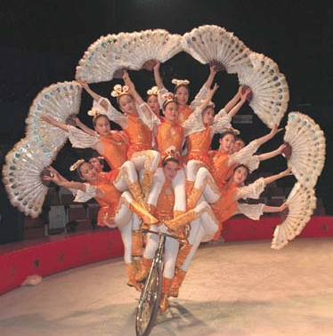

A special show to treat youngsters to is the circus at Cirque de Paris. This traditional circus offers the usual crowd-pleasing mixture of clowning, conjuring and death-defying acrobatics. A special day out can be arranged where children get to learn some of the circus arts, have dinner with the circus troupe and then get to watch the show.
Open: Oct-Jun only.
115 Boulevard Charles de Gaulle. Metro: Porte de Clignancourt. RER: St Denis.

Aeroparis - flying high over Paris
A huge tethered balloon in the southwest of the city allows people to climb aboard and get stupendous views over Paris from a height of 150m.
Open: daily 09h00-19h00.
Parc Andre Citroen, 2 Rue de la montagne de la Fage.
Métro/RER: Javel; RER: Bd Victor; Metro: Balard.

EXCURSIONS
There is a wealth of beautiful and interesting sights within a day's travel of Paris.

Versailles
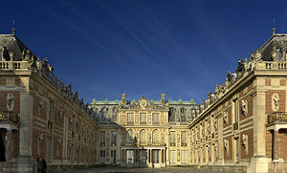
The royal palace at Versailles is what this delightful city just outside Paris is deservedly most famous for. The château de Versailles stands 24 Kms southwest of Paris and is one of France’s noted attractions. It is one of the finest examples of the 17th-century grand architecture. Built at the instigation of Louis (the proclaimed "Sun King") the palace was home to the royal family from 1682 until 1790. The most famous room in the palace is the Hall of Mirrors (Galerie des Glaces) where the Treaty of Versailles was signed, signifying the end of the Great War. Within the Palace visitors can also see the former Royal bedchambers, the grand staircase and the other staterooms, and within the vast landscape park and gardens are many wonderfully ornate fountains and ponds.
Opening hours: Versailles is closed on all Mondays
Versailles will be closed on 1st May and 8th May 2008

Brittany
Almost a kilometer off the Brittany coast, Mont St Michel is an amazingly atmospheric and unique place. When the sea is at low ebb you can easily walk to the tiny village along a causeway. When the tide comes in however, almost a kilometer of sea up to 14m deep separates the enclave from the mainland.
The village itself is a Gothic maze of staircases that progress up to the towering edifice of the abbey church. Although added to over the years it was the church that formed the original settlement of the mount, with the construction of a monastery in the 10th century. The town's defences are similarly spectacular and include towers and ramparts dating from various periods over the last millennium.

Charters
80km west of Paris lies Charters with its massive Notre Dame cathedral (dwarfing the dimensions of its namesake in Paris). The current cathedral dates from the 13th century and is a splendid example of Gothic architecture at its most magnificent.
The cathedral is home to the sacred relic of the Sainte Chemise, a garment of the Virgin Mary, and the nave still retains the labyrinth that the penitent pilgrims who came to see the relic walked round as they prayed. However, Chartres's history goes back even further than that of its cathedral. There is evidence of a Roman settlement here and the druids held their arcane rituals where the cathedral now stands. Wandering the narrow streets of the old town will reveal many fine examples of medieval architecture as well as more modern half-timbered buildings dating from the 15th and 16th centuries.

Around 70km south and west of Paris lie the most north-easterly reaches of the Loire Valley region. This massive expanse is liberally dotted with the finest châteaux in France. These examples of Renaissance architecture are remarkably well-preserved and the most famous draw thousands of visitors each year.
The best examples are the castles at Chambord and Chenonceau although Anet and Châteaudun are a lot closer to Paris. Even older, ruined fortresses and grand houses are interspersed among these sumptuous palaces as well, making it a remarkably rich area to explore.

Just 75km from Paris, Giverny is a totally separate world from the massive metropolis. The tiny town is a picturesque rural idyll in its own right although visitors tend to flock here for another reason - Claude Monet. The impressionist artist spotted Giverny when passing in 1883 and immediately moved his family into a farmhouse in the village.
He remained there until he died - and it was the garden of the house that was the subject of most of his paintings in the latter years of his life. Nearby lies the water garden that Monet created, and which was the subject of his most famous painting, Waterlilies. The garden and the house can still be visited and it is easy to imagine the artist being inspired by the lush richness of the flora here.

A medieval town, Rouen was for a long time a bone of contention between the English and the French - changing hands a few times in the two nations' many squabbles. Now it is a delightful settlement of half-timbered houses, steeped in history.
The most famous incident in the city occurred in 1431 when Joan of Arc was tried, condemned and burned at the stake in the town. Several museums commemorate the town's bloody history including one dedicated to Joan herself. The city's Notre Dame cathedral was extensively rebuilt after being horrendously damaged in World War Two. Rouen is an hour and a half's drive north-west from Paris.

Disneyland Paris:
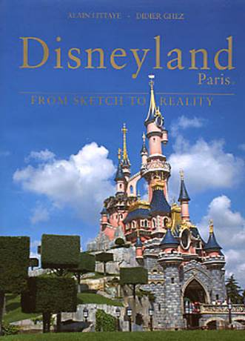
Disneyland Paris is located 32 kms east of Paris,
It doesn't really need much introduction. Disney's first theme park in Europe is just as impressive as the American equivalents, and just as packed with the usual Disney characters, rides and attractions. The trademark Disney Castle at the park was allegedly built bigger than any other in the world because of the competition of the real castles nearby.
Children and adults alike will love the parades and cartoon pageantry as much as ever and the French have even managed to instill the park with an air of gallic chic that is quite palpable to the visitor. It is possible to get a good meal here rather than the usual limp hotdogs and flat soft drinks of theme park cuisine, and the mouse even keeps a pretty good selection of wines to accompany the fine food. Not quite as much kids' stuff as you might think...

Fontainebleau
Fontainbleau forest is 64 kms south of Paris. It was a favourite hunting lodge of French kings in its day. Napoleon also sojourned here. The little Corporal's apartments have now been restored and are a feature of a tour of the palace and its grounds.
The surrounding forest makes a beautiful backdrop to the magnificent grandiosity of the architecture and it is easy to conjure up images of the royal hunts that must have ridden from the palace at one time. The nearby town of Barbizon is considered an artistic centre - Millet, Daubigny and Robert Louis Stevenson were just a few of the famous names that inhabited the town at one time.

Parc Asterix - themed fun
Everone's favourite cartoon gauls, Asterix and his friends are the theme behind this fun park just 30km north of Paris. The Goudurix roller coaster is the piece de resistance with no less than seven loops that only the bravest gaulish warriors can stomach, don't indulge on wild boar beforehand. As well as the rides the stage shows are guaranteed to amaze, particularly the stuntfest Main Basse Sur La Joconde ("Hands on the Mona Lisa") and the derring-do of D'Artagnan and the Three Musketeers at the ruined château. You can also visit the famous gaulish village and meet Asterix, Obelix and pals. WWith the Dolphinarium and a host of shops and restaurants to round-out the attractions a day might not be enough to see everything there is to see here. Opening hours vary so it is advisable to contact the park before you visit.
A1 Paris-Lille Highway. "Parc Asterix" exit between Sorties 7 and 8

PARIS PHRASEBOOK

French is the national language, although English is widely spoken. Below are some key phrases that may be useful during your visit to France.
ENGLISH | FRENCH | PRONOUNCED AS
Hello | Salut | sal oo
Good Morning / Afternoon | Bonjour | bon jor
Good Evening | Bonsoir | bon swar
Goodbye | Au revoir | oh ruh vwar
My name is... | Je m'appelle... | zhuh ma pell
One, two, three, four, five | Un, deux, trois, quatre, cinq | un, duh, twa, katr, sank
Thank you | Merci | mer see
Please | S'il vous plait | seel voo play
Excuse me | Pardon | par don
How much? | C'est combien? | say kom byan
Where is... ? | Où est... ? | oo ay
Ticket | Billet | bee ay
Bill | L'addition | ladee-syon
I would like | Je voudrais | zhuh voo dray
Is this the bus for... ? | Est-ce que ce bus va à... ? | es keh ser boos var ah
Where do I get off for... ? | Où dois-je descendre pour…? | oo dwah zhuh day sandra pour
Where are the toilets? | Où sont les toilettes? | oo son leh twah let
I'm looking for... | Je cherche... | zhuh shersh

Indian Restaurant in Paris

Allo Tandoori
Address:93, rue Philippe de Girard, 75018 Paris
Ph 0142058492

Banani
Address:148, rue de la Croix-Nivert, 75015 Paris
Ph 0148287392

Gandhi-Opéra
Address: 66, rue Ste Anne, 75002 Paris
Ph 0142605960

Joyti
148 rue de Vaugirard, 75015 Paris
Ph 47834545

Kastoori
4, place Gustave Toudouze, 75009 Paris
Ph 0144530610

Kohenoor
Address: 15 avenue Jean Jaurès, 75019 Paris
Ph 0142007581

La ville de Jagannath
Address:101, rue St Maur, 75011 Paris
Ph 0143558081

Mohit
Address:103, rue de montreuil, 75011 Paris
Ph 0143733221

Servaaheefh
Address:25, rue du Docteur Heulin, 75017 Paris
Ph 0142284340

French Riviera

The French Riviera or Cote d Azur refers to the country of the Alpes-Maritimes and the Principality of Monaco. It is located in the extreme south-east of France, next to the Italian border. With 300 days of sunshine a year the French Riviera is a popular destination both for leisure and business tourism.

Getting There
Air: The French Rivera shelters the 2nd International airport in France, Nice Cote d’ Azur International airport is centrally located , just 7 km from Nice city centre, 27 kms from Cannes and 33 Kms form Monaco.
Road: the motor way network links the French Riviera to the rest of Europe. Trip between Paris and Nice on the motorway takes 09 hours.
Trains: Fast trains link the French Riviera to all the other regions in France and to all the other cities in Europe. The high speed TGV trains connect Paris to Nice, Antibes and Cannes. Example: TGV Mediterranee Paris-Nice= 5 hrs 25 min.; TGV Avignon – Nice = 3 hours 15 mins; TGV Marseilles – Nice = 2 hrs 30 min.

Main Destinations and Highlights on the Riviera

NICE

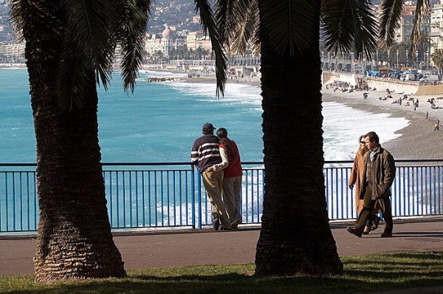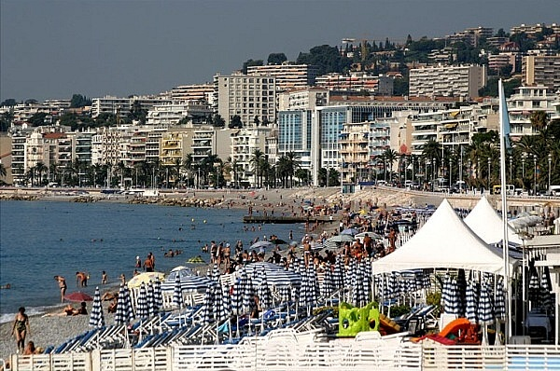
Bay of Angel Promenande des Anglais

The capital of the Riviera and fifth largest city in France, The clients can stroll along the worl famous Promenande des Anglais. A kilometre or so down the promenade and a couple of blocks inland at 33 av des Baumettes is the Musée des Beaux-Arts (Tues–Sun 10am–noon & 2–6pm; bus #38, stop "Chéret"). Continuing southwest along the promenade des Anglais towards the airport, you'll find the Musée International d'Art Naïf Anatole Jakovsky (daily except Tues 10am–noon & 2–6pm; home to a refreshingly different, and surprisingly good, collection of over six hundred pieces of amateur art from around the world. The beach below the promenade des Anglais is all pebbles and mostly public, with showers provided. It's not particularly clean and you need to watch out for broken glass. There are, of course, the mattresses, food and drinks concessionaries, but nothing like to the extent of Cannes. On the hill to the east, prehistoric life in the region has been reconstructed on the site of an excavated fossil beach in the well-designed Musée de Terra Amata, 25 bd Carnot (Tues–Sun 9am–noon & 2–6pm).
Visit the flower market on Cours Saleya (every morning except Monday, when there is an antiques market).
It is located in the downtown shopping area.
One can explore the old town with its typical alleyways, artist and craftsmen and women. Place Massena. Colline du Chateaux for a fabulous panorama of the Baie des Anges (Bay of Angels). Also Nice is very famous for

Matisse and Chagall museums. 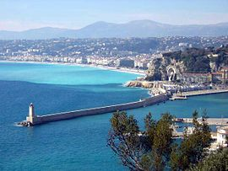
Nice is a city in southern France located on the Mediterranean coast, between Marseille, France, and Genoa, Italy, with 1,197,751 inhabitants in the metropolitan area at the 2007 estimate. The city is a major tourist centre and a leading resort on the French Riviera (Côte d'Azur). It is the historical capital city of the County of Nice.
One should be aware that the official Nice temperatures are recorded at the airport, which is a climatically different place than the rest of the town, being more vulnerable to marine air and winds from the Var valley. Airport temperatures are therefore different from town ones : daytime airport temperatures are slightly higher, while nighttime temperatures are significantly lower. For example, on the 24th of January 2007, a minimum of 0.9°C was recorded at the airport while the temperature didn't go below 6°C in the city itself. The following statistics and descriptions use official temperatures.
Nice has a Mediterranean climate : the city enjoys mild temperatures most of the year; rainfall is very moderate and mainly concentrated in the darkest part of the year (September to March).
Winters, starting in December, are cool to mild with daytime temperature generally remaining between 10°C and 17°C and colder overnight lows. However, the temperature rarely reaches freezing point, which occur only once or twice a year. During winter, overcast skies are common and sporadic rain falls.
As winter ends in March, weather becomes more unstable and unpredictable : warm, sunny days (26°C the 2nd of March 2007) can be followed by sudden hailstorms and cold fronts (7°C the 1st of April 2007).
However, generally, the weather becomes increasingly sunny as summer approaches.
Summers start quite late because of a notable season lag. Drought starts in July, and really hot temperatures become common in August, which is the warmest month with daytime highs frequently reaching 35°C. Summer heat is however often moderated by a cool and pleasant sea breeze.
Autumn, starting in late September, is generally warm until mid-November, and rainy (especially October with an average rainfall of 140mm).
Nice is a windy city, especially in spring.
Snow is so rare that it is remembered by inhabitants as special events.
Climate Table
 | Jan | Feb | Mar | Apr | May | Jun | Jul | Aug | Sep | Oct | Nov | Dec
Mean daily maximum temperature (°C) | 13 | 13 | 15 | 17 | 20 | 24 | 27 | 28 | 25 | 21 | 16 | 14
Mean daily minimum temperature (°C) | 6 | 6 | 8 | 10 | 14 | 17 | 20 | 20 | 17 | 14 | 9 | 6

Nice Côte d'Azur Airport
The Côte d'Azur International Airport or Nice Côte d'Azur Airport (French: Aéroport Nice Côte d'Azur) (IATA: NCE, ICAO: LFMN) is an airport in Nice, in the Alpes-Maritimes department of France. It is the third most important airport in France after Charles de Gaulle International Airport and Orly Airport, both in Paris. It is on the Promenade des Anglais, near l'Arénas and has two terminals. Due to its proximity to the Principality of Monaco, it also serves as that city-state's airport, with helicopter service linking the city and airport.
It is run by the Chamber of Commerce and the Nice Côte d'Azur industry. Its director is Hervé de Place, director of the Côte d'Azur airports, which includes Côte d'Azur International Airport's cousin airport, Cannes-Mandelieu. In 2006, 9,948,035 passengers travelled through the airport.

Places of interest
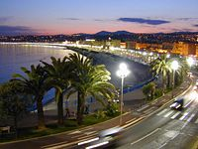

Promenade des Anglais
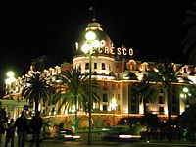

Hotel Negresco
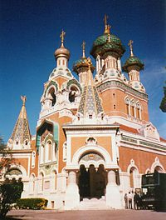

Saint Nicolas Orthodox Cathedral
The Promenade des Anglais ("Walk of the English") is a celebrated promenade along the Mediterranean at Nice, France. Before Nice was urbanized, the coast at Nice was just bordered by a deserted band of beach covered by large pebbles. The first houses were located on higher ground well away from the sea.
Starting in the second half of the 18th century, the English took to spending the winter in Nice, enjoying the panorama along the coast. When a particularly harsh winter up north brought an influx of beggars to Nice, some of the rich Englishmen proposed a useful project for them: the construction of walkway (chemin de promenade) along the sea.
The city of Nice, intrigued by the prospect of a pleasant promenade, greatly increased the scope of the work. The Promenade was first called the Camin dei Anglès (the English Way) by the Niçois in their native dialect Nissart. After the annexation of Nice by France in 1860 it was rechristened La Promenade des Anglais, replacing the former Nissart name with its French translation.
The Hotel Negresco on the Promenade des Anglais on the Baie des Anges in Nice, France was named for Henri Negresco (1868-1920) who had the palatial hotel constructed in 1912. In keeping with the conventions of the times, when the Negresco first opened in 1913 its front opened on the side opposite the Mediterranean.
- Château
- Monument aux morts
- The port
- Cours Saleya
- Musee Massena
- Marché aux fleurs
- Old Nice
- Grand Hôtel Impérial
- Fort du MontAlban
Religious
- Sainte-Réparate Cathedral, 17th century
- Saint-Jacques Church, 17th century
- The Saint Nicolas Orthodox Cathedral
- Sainte Jeanne d'Arc Church, 20th century

Squares
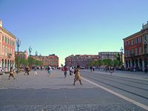

View of the Place Masséna
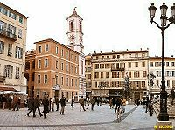

Place du Palais view of the Rusca palace
Like any Mediterranean city, the town of Nice has squares; allowing people to gather, to organize great shows, performances or public display, or just to sit down at a terrace.

Place Masséna
The Place Masséna is the main square of the city. Before the covering of the Paillon River, the Pont-Neuf was the only practicable path between the old town and the modern one. The square was thus divided into two parts (North and South) in 1824. Since the destruction of the Masséna Casino in 1979, the Place Masséna became more spacious and less dense and is now bordered by red ochre buildings of Italian architecture.
The recent re-building of the tram gave the square back to the pedestrians, restoring its status of a real Mediterranean square. It is lined with palm trees and stone pines, instead of being the rectangular roundabout of sorts it had become over the years. Since its construction, the Place Masséna has always been the spot for great public events. It is used for concerts, and particularly during the summer festivals, the Corso carnavalesque (carnival parade) in February, the military procession of July 14th (Bastille Day) or other traditional celebrations and banquets.
The Place Masséna is a two-minute walk from Promenade des Anglais, old town, town centre, and Albert I Garden (Jardin Albert Ier). It is also a large crossroads between several of the main streets of the city: avenue Jean Médecin, avenue Felix Faure, boulevard Jean Jaurès, avenue de Verdun and rue Gioffredo.

Place Garibaldi
The Place Garibaldi also stands out for its architecture and history. It is named after Giuseppe Garibaldi, hero of the Italian unification (born in Nice, which was still a part of Sardinia-Piedmont at the time), who was ferociously attached to the union of Nice to Italy.
A Statue of Garibaldi is erected in the centre of the place. The re-building of the square (still ongoing) will make this square semi-pedestrian, making it more pleasant.
It is a crossroads between the Vieux Nice (old town) and town centre. Place Garibaldi is close to the eastern districts of Nice, Port Lympia (Lympia Harbor), and the TNL commercial centre. This square is also a crossroads of important streets : the boulevard Jean Jaurès, the avenue de la république, the rue Cassini and the rue Catherine Ségurane.

Place Rossetti
Entirely enclosed and pedestrianised, this square is located in the heart of the old town. With typical buildings in red and yellow ochres surrounding the square, the cathédrale Sainte-Réparateand the fountain in the centre, place Rossetti is a must-see spot in the old town. By day, the place is invaded by the terraces of traditional restaurants and the finest ice-cream makers. By night, the environment changes radically, with tourists and youths flocking to the square, where music reverberates on the walls of the small square. The square's lighting at night gives it a magical aspect.
Place Rossetti is in the centre of the old town, streets Jesus, Rossetti, Mascoïnat and the Pont-vieux (old bridge)

Cours Saleya
In the past, it belonged to the upper classes. It probably is the most traditional square of the town, with its daily flower market. The court Saleya also opens on the Palais des rois Sard (Palace of the Kings of Sardinia). In the present, the court is mostly a place of entertainment. There are good restaurants serving typical Nicois cuisine, markets and many pubs. It is no doubt one of the most active spots in Nice.
It is situated parallel to the Quai des Etats-Unis.

Place du Palais
As its name indicates, the place du palais is where the Palais de Justice (Law courts) of Nice is located. On this square, there also is the Palais Rusca, which also belongs to the justice department (home of the tribunal de grande instance).
The square is also notable due to the presence of the city clock. Nowadays, the Place du Palais is alive day and night. It is particularly appreciated by youths who hangout on the steps leading to the Palais de justice, often with alcoholic bottles in hand. The place is not a large open-air bar, though, concerts, animations and events are frequent.It is situated halfway between cour Saleya and place Masséna.

Nice Observatory
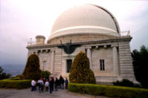

View of the Bischoffsheim cupola, main cupola of Nice Observatory
The Observatoire de Nice (Nice Observatory) is located on the summit of Mont Gros. The observatory was initiated in 1879 by the banker Raphaël Bischoffsheim. The architect was Charles Garnier, and Gustave Eiffel designed the main dome.
The 76-cm (30-inch) refractor telescope that became operational in 1888 was at that time the world's largest telescope. It was outperformed one year later by the 36-inch (91-cm) refractor at the Lick Observatory.
As a scientific institution, the Nice Observatory no longer exists. It was merged with CERGA in 1988 to form the Observatoire de la Côte d'Azur.

Gastronomy
The cuisine of Nice uses resources of the local countryside (olive oil, anchovies, fruit and vegetables) but also resources from more remote regions, in particular those from Northern Europe because ships which came to seek olive oil arrived full with food products. Thus one finds specialities such as those using stockfish made from dried haddock.
Local meat comes from neighbouring valleys, such as the sheep of Sisteron. Local fish, such as mullets, bream, sea urchins, and anchovies (alevins) are used to a great extent, so much so that it has given birth to a proverb: "fish are born in the sea and die in oil.” Naturally, this refers to the olive oil made in the Nice hills. Indeed, seafood is generally much appreciated in the delicate and healthy cuisine of Nice.
Examples of Niçois specialties include:

- Beignets de fleurs de courgettes
- Ratatouille
- Pichade
- Pissaladière
- Pan-bagnat
- Socca
- Soupe au pistou
- Tourte de blettes
- Daube

Indian Restaurants in Nice:

Achiana
Address: 29 rue Assalit, 06000 Nice
Mother India
Address: 5 Rue Gilly, 06300 Nice

Noori’s
Address: 1 Place Grimaldi, 06000 Nice

Eelam
Address: 51 Boulevard Pierre Sola, 06300 Nice
Esan
Address: 17 Rue St Philippe, 06000 Nice
Marseille
Marseille, is the second-largest city of France and forms the third-largest metropolitan area, after Paris and Lyon. Located on the south east coast of France on the Mediterranean Sea, it is France's largest commercial port. Its inhabitants are called Marseillais.
Geography
Marseille is the largest and most populous commune in France after Paris and is the centre of the third largest metropolitan area in France. To the east, starting in the small fishing village of Callelongue on the outskirts of Marseille and stretching as far as Cassis, are the Calanques, a rugged coastal area interspersed with small fjords. Further east still are the Sainte-Baume, a 1,147 m (3,763 ft) mountain ridge rising from a forest, the town of Toulon and the French Riviera. To the north of Marseille, beyond the low Garlaban and Etoile mountain ranges, is the 1,011 m (3,317 ft) Mont Sainte Victoire. To the west of Marseille is the former artists' colony of l'Estaque; further west are the Côte Bleue, the Gulf of Lion and the Camargue region in the Rhone delta. The airport lies to the north west of the city at Marignane on the Etang de Berre.
The city's main thoroughfare, the wide boulevard called the Canebiere, stretches eastward from the Old Port (Vieux Port) to the Réformés quarter. Two large forts flank the entrance to the Old Port - Fort St Nicholas on the south side and Fort St Jean on the north. Further out in the Bay of Marseille is the Frioul archipelago which comprises four islands, one of which, The main commercial centre of the city intersects with the Canebière at rue St Ferreol and the Centre Bourse (the main shopping mall). The centre of Marseille has several pedestrians zones, most notably rue St Ferreol, Cours Julien near the Music Conservatory, the Cours Honoré-d'Estienne-d'Orves off the Old Port and the area around the Hotel de Ville. To the south east of central Marseille in the 6th arrondissement are the Prefecture and the monumental fountain of Place Castellane, an important bus and metro interchange. To the south west are the hills of the 7th arrondissement, dominated by the basilica of Notre-Dame-de-la-Garde. The railway station - Gare de Marseille Saint-Charles - is north of the Centre Bourse in the 1st arrondissement; it is linked by the Boulevard d'Athènes to the Canebière.

Climate
Marseille has a Mediterranean climate, with mild, humid winters and hot, dry summers. January and February are the coldest months, averaging temperatures of around 8 to 9 °C. July and August are the hottest months. The mean summer temperature is around 23 to 24 °C (75 °F). In July the average maximum temperature is around 30°C.[ Marseille is known for the Mistral, a harsh cold wind originating in the Alps that occurs mostly in winter and spring. Less frequent is the Sirocco, a hot sand-bearing wind, coming from the Sahara desert.
Month | Jan | Feb | Mar | Apr | May | June | Jul | Aug | Sept | Oct | Nov | Dec
Avg high °C (°F) | 11.2 (52.2) | 12.6 (54.7) | 15.3 (59.5) | 17.7 (63.9) | 22.2 (72.0) | 26.1 (79.0) | 29.5 (85.1) | 29.2 (84.6) | 25.3 (77.5) | 20.3 (68.5) | 14.7 (58.5) | 12.0 (53.6)
Avg low °C (°F) | 3.0 (37.4) | 3.9 (39.0) | 6.0 (42.8) | 8.5 (47.3) | 12.6 (54.7) | 16.0 (60.8) | 18.7 (65.7) | 18.7 (65.7) | 15.5 (59.9) | 11.6 (52.9) | 6.8 (44.2) | 4.1 (39.4) | 10.5 (51.0)

Gastronomy

Fish soup with rouille
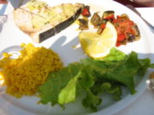

Swordfish in olive oil with ratatouille and saffron rice
- Pastis, an alcoholic beverage made with aniseed and spice
- Aïoli, a sauce made from raw garlic, lemon juice, eggs and olive oil, served with boiled fish, hard boiled eggs and cooked vegetables[30]
- Tapenade, a paste made from capers, chopped olives and olive oil (sometimes anchovies may be added)
- Bouillabaisse, a fish soup containing assorted shellfish, fish and vegetables, served with rouille, toasted bread (croûtes) and often grated cheese [31] [32]
- Anchoïade, a paste made from anchovies, garlic, black olives and olive oil, served with raw vegetables
- Panisse, a pastry made from chickpea flour
- Navette, a small hard biscuit in the shape of a boat, flavoured with orange blossom[33]
- Bourride, a fish dish made with monkfish, mayonnaise and a vegetable brunoise [34]
- Pieds-paquets, a dish prepared from pig's trotters, sheep or pork tripe and lard

Places of interest

[edit] Central Marseille
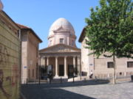

La Vieille Charité
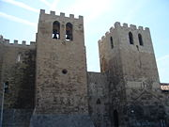

The Abbey of St Victor
Marseille is listed as a major centre of art and history. The city boasts many museums and galleries. There are many ancient buildings and churches of historical interest. Most of the attractions of Marseille (including shopping areas) are located in the 1st, 2nd, 6th and 7th arrondissements.
These include:
- The Old Port or Vieux-Port, the main harbour and marina of the city. It is guarded by two massive forts (Fort St Nicolas and Fort Saint Jean) and is one of the main places to eat in the city. Dozens of cafés line the waterfront. The Quai des Belges at the end of the harbour is the site of the daily fish market. Much of the northern quayside area was rebuilt by the architect Fernand Pouillon after its destruction by the Nazis in 1943.
- The Phare de Sainte Marie, a lighthouse on the inlet to the Old Port.
- La Vieille Charité in the Panier, an architecturally significant building designed by the Puget brothers. The central baroque chapel is situated in a courtyard lined with arcaded galleries. Originally built as an alms house, it is now home to an archeological museum and a gallery of African and Asian art, as well as bookshops and a café.
- The Centre Bourse and the adjacent rue St Ferreol district (including rue du Rome and rue Paradis), the main shopping area in central Marseille. (The other two major shopping complexes in Marseille are at la Valentine and le Grand Littoral.)
- The Musée d'Histoire, the Marseille historical museum, located in the Centre Bourse. It contains records of the Greek and Roman history of Marseille as well as the best preserved hull of a 6th century boat in the world. Ancient remains from the Hellenic port are displayed in the adjacent archeological gardens, the Jardin des Vestiges.
- The Palais de la Bourse, a 19C building housing the chamber of commerce, the first such institution in France. It also contains a small museum, charting the maritime and commercial history of Marseille, as well as a separate collection of models of ships.
- The Musée de la Mode, a museum of modern fashion which displays over 2000 designs from the last 30 years.
- The Musée Cantini, a museum of modern art near the Palais de Justice. It houses artworks associated with Marseille as well as several works by Picasso.
- The Pierre Puget park.
- The Hotel-Dieu, a former hospital in the Panier, currently being transformed into an Intercontinental hotel.
- The Abbey of Saint-Victor, one of the oldest places of Christian worship in France. Its early fifth century crypt and catacombs occupy the site of a Hellenic burial ground, later used for Christian martyrs and venerated ever since. Continuing a medieval tradition, every year at Candlemas a Black Madonna from the crypt is carried in procession along rue Sainte for a blessing from the archbishop, followed by a mass and the distribution of "navettes" and green votive candles.
- The Hotel de Ville (the Town Hall), a baroque building from the seventeenth century.
- The Museum of Old Marseille, housed in the 16C Maison Diamantée, describing everyday life in Marseille from the eighteenth century onwards.
- The Cathedral of Sainte-Marie-Majeure or la Major, founded in the 4th century, enlarged in the 11th century and completely rebuilt in the second half of the 19th century by the architects Léon Vaudoyer and Jacques Henri Esperandieu. The present day cathedral is a gigantic edifice in the Romano-Byzantine style. A romanesque transept, choir and altar survive from the older medieval cathedral, spared from complete destruction only as a result of public protests at the time.
- The 12C parish church of Saint-Laurent and adjoining 17C chapel of Sainte-Catherine, on the quayside near the Cathedral, recently reopened after restoration.

Outside of Central Marseille
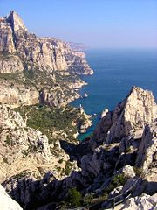

The Calanque of Sugiton in the 9th arrondissement of Marseille
- The nineteenth century Basilica of Notre-Dame-de-la-Garde, built by the architect Esperandieu, is an enormous Romano-Byzantine basilica in the hills to the south of the Old Port. The terrace offers spectacular panoramic views of Marseille and its surroundings.
- The Stade Velodrome, the home stadium of the Marseille football team "OM", Olympique de Marseille.
- The Gare Saint-Charles, the main railway station. Below it is the royal Porte d'Aix (1784-1837), a giant triumphal arch, at the crossroads to Aix.
- The Unite d'Habitation, an influential experimental building designed by the Swiss architect Le Corbusier in the late forties
- The Musée des Beaux-Arts and the Natural History Museum are housed in the two wings of the nineteenth century Palais Longchamp, also designed by Esperandieu. Built on a grand scale, this Italianate colonnaded building rises up behind a vast monumental fountain with cascading waterfalls. The jeux d'eau marks and masks the entry point of the Canal de Provence into Marseille.
- The Grobet-Labadié museum, opposite the Palais Longchamp, houses an exceptional collection of European objets d'art and old musical instruments.
- The parc Borély, a park off the Bay of Marseille with botanical gardens.
- The Musée de Faience, a ceramics museum in the Chateau Pastre near the parc Borely.
- The parc Chanot, an exhibition centre.
- The Pharo Gardens, a park with views of the Mediterranean and the Old Port.
- The Corniche, a picturesque waterfront road between the Old Port and the Bay of Marseille.
- The Museum of Contemporary Art, devoted to American and European art from the 1960s to the present day.
- The local beaches at the Prado, Pointe Rouge, les Goudes, Callelongue, and le Prophète.
- The Musée du Terroir Marseillais in Chateau-Gombert, devoted to provencal crafts and traditions.
- The calanques and Marseilleveyre, a wild mountainous coastal area of outstanding natural beauty, accessible from Callelongue, Luminy, Sormiou, Morgiou and Cassis.
- The islands of the Frioul archipelago in the Bay of Marseille, accessible by ferry from the Old Port. The prison of Château d'If was the setting for the Count of Monte Cristo, the novel by Alexandre Dumas. The neighbouring islands of Ratonneau and Pomègues are joined by a man-made breakwater. The site of a former garrison and quarantine hospital, these islands are also of interest for their marine wildlife.
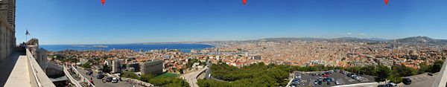

Panorama of Marseille from Notre-Dame-de-la-Garde

Transport
The city is served by an international airport, Marseille Provence Airport, located in Marignane. The airport has two terminals. Terminal one, the main terminal of the airport contains halls 1,2,3 and 4 and serves as a base for international arrivals and departures. The new terminal, referred to as Marseille Mp2 is used for flights arriving and departing from Europe. A shuttle coach system operates between the airport and the railway station, Gare de Marseille Saint-Charles.
An extensive network of motorways connects Marseille to the north and west (A7), Aix-en-Provence in the north (A51) , Toulon (A50) and the French Riviera (A8) to the east.
Gare de Marseille Saint-Charles is Marseille's main railway station. It operates direct regional services to cities such as Nice, Toulouse and Bordeaux, as well as a service to Barcelona. (The northerly single track line to Briancon via Aix-en-Provence is currently partially closed during modernisation.) Gare Saint-Charles is also one of the main terminal stations for the TGV in the south of France making Marseille reachable in three hours from Paris (a distance of over 750 km). and just over one and a half hours from Lyon. There is also a direct TGV line to Strasbourg.
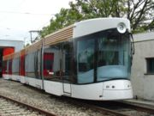

The new tramway.
There is a long distance bus station, still under construction, adjacent to Gare Saint-Charles with destinations mostly in the Bouches-du-Rhône. Temporarily buses to Aix-en-Provence depart from the nearby Porte d'Aix. Other buses to Cassis, La Ciotat and Aubagne depart from Castellane.
Marseille has a large ferry terminal, the Gare Maritime, with services to Corsica, Sardinia, Algeria and Tunisia. A ferry service on a quite different scale operates between the two opposite quays of the Old Port.
Marseille itself is connected by the metro train system operated by the Régie des transports de Marseille (RTM). It consists of 2 lines represented by orange and blue. Line 1 (blue) between Castellane and La Rose opened in 1977 and Line 2 (orange) between Sainte-Marguerite/Dromel and Bougainville opened between 1984 and 1987. An extension to Line 1 from Castellane to La Timone was completed in 1992. The Metro system operates on a turnstile system, with tickets purchased at the nearby adjacent automated booths. Both lines of the Metro intersect at Gare Saint-Charles and Castellane.
An extensive bus network serves the city and suburbs of Marseille. The first phase of a new tramway, going eastwards from the port towards St Barnabé, was opened in July 2007.

CANNES
In Cannes one can stroll along te famous Croisett (palace-hotel and luxury boutiques) Festival Hall. There are luxury boutiques in Rue d’ Antibes. One can also explore Cannes old town with its daily Provencl market (“Forville”) Explore the medival neighbourhood of Le Suquet with its superb view of the old port and the Bay of Cannes. Take a boat from Cannes to the Lerins Island (Sainte Marguerite with its fortress and Saint Honort with its monastery). The shopping festivals is held n Cannes in January

THE PRINCIPALITY OF MONACO
Visit the Prince’s Palalce (on the Rocks) with the changing of the Guards every day at 11:55 am. There are famous casinos AND SHOPPING AREAS WITH LUXURY SHPS. The Jardin Exotique overlooking the bay gives a very panoramic view. The visitorts can also visit the Musee Oceanographique (Oceanological Museum).

ANTIBES-JUAN-LES-PINS
Stroll around the port Vauban and explore the old town with its ramparts and 3000 years of history. Wander through typical alleys, the Provencal market on cours Massena (except Mondays), the very picturesque “Safranier” neighbourhood. Visit the Picasso and Peynet Museum. Follows the walk around Cap d’Antibes

GRASSE
Explore the medieval town centre with its cathedral constructed in the 13th century, its medieval houses and streets. Place aux Aires with its colourful market.
Visit the famous perfumeries (Fragonard, Molinard and Galimard). Attend a workshop on creating perfumes or aromatherapy to learn about the virtues and beneficial effects of plants. Visit the International Perfumery Museum to discover the various processes involved in making perfume and a remarkable collection of perfume bottles.

THE VILLAGE OF SAINT PAUL-DE-VENCE
Ranked as one of the most beautiful villages in France. An internationally renowed centre of art. Explore the medievaltowns with its alleys, ramparts and art galleries. Visit the Fondation Maeght, a high temple of contemporary art on the Franvh Riviera

THE VILLAGE OF EZE
Explore the medieval village, its narrow streets and crafts. Visit Eze Garden with their exceptional panorama of the French Riviera.
Visit the Fragonard and Galimard perfumeries.

ST. TROPEZ
This city offers an eclectic atmosphere and casual ambience that blends beautifully with the many glamour’s yachts and sailboats. Cobblestone streets lead to alleys housing some of the most stylish shops, galleries, hotels and restaurants. Apart from the choice shopping and night life scenes, there are also forty private beaches that provide seclusions and encourage a seductive mood. Extraordinary views of Citadelle, the Mediterranean Sea, and the surrounding mountains can be enjoyed from almost any point in the area.

Rhone – Alps

Perfectly situated in the heart of France, midway between Paris and Cot d’Azur, sharing its mountainous borders with Switzerland and Italy, the Rhone alps, mainly compose of French Alps and the Rhone Valley, offers the most gorgeous of France.

Getting There
This region is easily accessible by air, thanks to the 2 International airports; Lyon St Exupery and Geneva airport: Direct flights from India to Paris and then connecting flights to Lyon (a 45 min flight) or take high speed TGC train from Paris to Lyon (02 hours). Each city and resort can be reached by TGV from Paris.

Main Regions

LYON
Lyon unveils its architecture just like a history book, as you pass from the district to the next. It opens up its heart and its treasures as you stroll along its streets, through the maze formed by its “traboules” and hillsides and down its bustling riverbanks. The old tradition still remains alive and the entire city is deeply marked ny its past. Renowned first and foremost as a gastronomic capital, France's second city should be at the top of the list of travel destinations on any gourmet's itinerary. From regional specialities in cosy, traditional restaurants to extravagant, modern cuisine in state-of-the-art eating emporiums Lyon offers something for everyone.
You don't need to look too hard to find some of Lyon's greatest facets, though as they are all around you once you step into the old town. In one of the most beautiful Renaissance towns of Europe, immaculately preserved houses and shops line quaint cobbled streets retaining much of the atmosphere of centuries past. It's here that you are at the heart of the real Lyon, and where you can enjoy the city's famous cuisine in the lively bouchons (traditional inns), where you can't fail to be seduced by the city's charms.
Heading North is the renowned Burgundy region where some of the world’s finest wines can be discovered. From the Côte de Beaune to the unforgettable Pouilly-Fuissé, it will be a constant pleasure for your palate. The best way to sample all these wonderful flavours and find out more on where they are actually produced is to follow some wine routes such as the “Route Touristique des Grands Vins” around Chalon-sur-Saône, “Route des Grands Crus” from Dijon to Santenay, and “Route des Vins Mâconnais-Beaujolais”. For more information, contact the Burgundy Tourist Office. Tel: +33 (0)3-8028-0300.

Indian Restaurants in Lyon:

La cours des Loges
Address: 6, rue du boeuf, 69005 Lyon

CHAMONIX – MONT BLAC

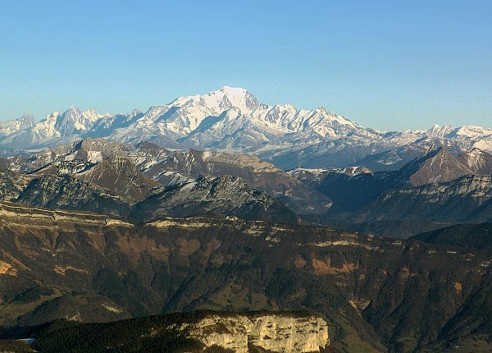

High Mountains scenery, the sheer beauty of which will take your breath away, majestic ice falls and glaciers, one of Europe’s highest cable cars, cog railways that take you on a journey through time, a beautiful alpine town, witness to 250 years of mountaineering history, traditional villages and hamlets scattered along the 20 kms long valley and above all a heart and soul, beating to the rhythm of all those that live and love Chamonix!. Chamonix lies in one of the most spectacular valleys of the French Alps. Deeply crevassed glaciers and the cloud – diademed peak of Monty Blac dominate the area. The Aigulle du Midi, a solitary spire of rock near Mont Blac’s summit, has postcard – pertfect views. Chamonix Mont-Blac is situated at 88 kms from Geneva-Cointrin (1 hour) International airport; 220 km from Lyon-St-Exupery International airport and 171 km from Turin – Caselle International airport.
They are fluent in English.There are also daily public transport services from Geneva airport through the bus ST company; Turin aiport through the bus SAVDA company and Lyon airport by train. The TGV also journeys from Paris to Annecy, Lyon, Bellegrade, Aix Les Bains. The Mont - Blanc Express services the Chamonix Valley from Saint Gervais les Bains to Vallorchine at the swiss border.

COURCHEVEL

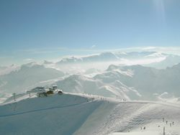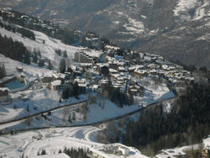

Courchevel is the name of a ski area located in the Savoie region of the French Alps, and part of Les Trois Vallées, the largest linked ski area in the world. The original resort was planned during the Second World War. Courchevel's airport also has a certain degree of infamy in the aviation industry as home to one of the shortest runways in the world, with a length of 525 m. Courchevel plays host to the rich and famous and is without doubt, France's premier resort. With luxury chalets in Courchevel, perfectly groomed runs and an excellent ski record, it's easy to see why people return to Courchevel year after year. Courchevel itself is really a series of smaller villages whose names reflect their heights in meters—Courchevel 1850, Courchevel 1650, Courchevel 1550 and so on. Courchevel 1300, also called Le Praz, is the quaintest, but its lower altitude may mean a sacrifice of snow for charm. There is another village, Saint-Bon on a fifth level (but with no lifts). Courchevel l850 is the highest and priciest, but it’s also where most trails run right outside your hotel or apartment door. It is where the best restaurants are found and where the nightlife continues until the sky begins to lighten with coming day. Built for ski-in/ski-out, Courchevel 1850 really works. Its lift system covers both sides of the valley. The world’s largest cable car, heading up to La Saulire (8,885 feet), connects Courchevel to the rest of the Les Trois Vallées area.
La Tania is a small separate resort set at the base of the ridge separating Courchevel and Méribel. It has its own relatively quiet nightlife. From La Tania it is about a half-hour bus ride to either of the larger resorts straddling the ridge. Website: www.courchevel.com

LAKE ANNECY

A splendid town full of art treasures, as well as the perfect city for sports and leisure activities. See it and experience it for yourself. It is also a centre for business and tourism with a human dimension.

From Annecy to:
Chambery | 47km
Geneva | 39km
Grenoble | 103km
Lyon | 130km
Paris | 550km
Albertville | 45km
Chamonix | 92km
La Clusaz | 32km
Megeve | 60km
Flight routes to Annecy region
Airline | Routes | Website
Ryanair | Stansted to St Etienne | www. ryanair.com
British Airways | London Heathrow to Geneva  Manchester to Geneva & Lyon  Birmingham to Geneva & Lyon | www.britishairways.co.uk
EasyJet | Fly from:  Gatwick, Luton, East-Midlands,  Liverpool, Bristol, Stanstead, Newcastle to Geneva | www.easyjet.com
Swiss | London Heathrow to Geneva  London City to Geneva  Manchester to Geneva via Zurich
By Road:
Eurotunnel Folkestone - Calais
Seafrance Dover - Calais
Hoverspeed Dover - Calais
Recommended driving route from Calais:
From EuroTunnel or Port take Peage motorway direction Reims E17 - continue to Dijon
At Macon turn off onto $40 direction Geneva and Annecy, before Geneva turn off towards Annecy.
Total distance: 500miles (800km)
Approx Journey Time: 9 - 10 hours
Cheap Cross-Channel Bookings try: www.xchannel.co.uk
By Train:
Eurostar Waterloo and Ashford to Annecy, via Paris try: www.skitrain.co.uk

Upcoming Destinations and Other Attraction:

- Wine Rigions in France
BURGUNDY
Ideally located between Paris and Lyon, 3hoursby road and TGV(1 hour 40 min).
Burgundy offers you prestigious vineyards and wines, historical cities and famous world sights such as Vezelay and Fontenay, as well as a particularly interesting boating network.
Key attractions are the Route Des Grands Crus, Tourisitique Des Vignobles De L’yone and Route of the Burgundian Dikes and the Chateaux of the Southern Burgundy.

CHAMPAGNE

The city of Reims is about 2 hours by train from Paris. Among hillsides, river, renowned world heritage monuments or hidden secrets, nestle vineyards planted with Chardonnay, Pinot Noir and pinot Menuir, the grape varities from which the most famous of the celebratory wines is derived: Champagne.

BRODEAUX

The city is unknown as the world’s wine capital, hosting the wine industry’s biggest event worldwide: Vinexpo. You can reach Bordeaux in 3 hours from Paris by TGV.

ALSACE
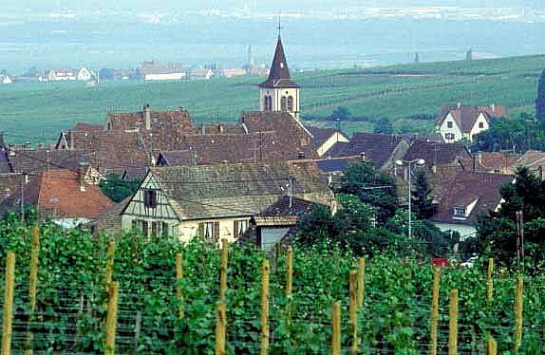

Alsace is the capital of Strasbourg. Strasbourg is ideally situated in the centre of Europe – at 2 hours by coach from Frankfurt airport, 1 hour by plane from Paris and 2 hrs 30 mins by TGV from Paris. At the foot the wooded slopes of the Vosges, dominated by mysterious chateaus, Alsace reveals its prettiest wine-making villages. Strasbourg is the main city of Alsace, a region famous for its gastronomy and white wines and has been classified as a world heritage by UNESCO. December in Strasbourg means above all, the immense Christmas, which has been in existence for 434 years.

LANGUEDOC
The city of Montpiellier is about 4 hrs from Paris.The vineyards stretch from the area of Nimes and the Pont du gard to beyond Narbonne and Carcassonne. Ramblers path, vineyard museums and tourist itineraries invite you to discover them. Thw eine growers offer stay on the theme of wine and the heritage that surrounds it.

PROVENCE
The town of Marseilles is about 3 hours away from Paris
Today, the red rose and the white wines of Provence that have inherited this tradition are grown in this Mediterranean soil, as strong and robust as the wine growers themselves. A land full of discoveries for lovers of the good life, the vineyards of Provence are the rich in significant and important sites.

LOIRE VALLEY

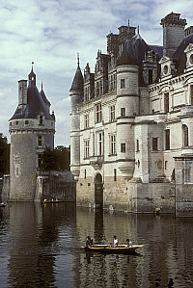

This city is just 1 hr 30 min. away from Paris. The tourist rout around the vineyards of the loire valley leads wine lovers and the beginners alike from cellar t vineyard, offering wine related discoveries punctuated by visits to imposing castles, abbeys, cave dwellings and gardens along the Loir, now classed as part of the world heritage of mankind by UNESCO. The region's heartland Touraine, long known as "the garden of France", has the best wines, the tastiest goat's cheese, and the most regal history and, it's argued, the purest French accent in the land. It also has one of the finest Château in Chenonceau and by far the most developed tourist industry to match.

